System Security: Touch Screen

| August-20 |

**Document Overview**

**Documentation Goals**

This documentation is intended to provide instruction for ***Security within the Touch Screen Programs****.*

**Table of Contents**

**Touch Screen Transaction Time Security** 2

Program Master [NS8] 2

Browse Programs 2

View Programs 2

User Groups 3

Plant Data Collection Security 3

# **Touch Screen Transaction Time Security**

## Program Master [NS8]

### Browse Programs

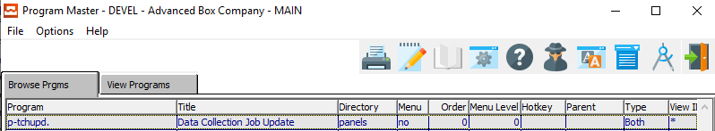

The user can search for their desired program by using the *Auto Find* search box at the bottom of the screen.



Security for *Plant Data Collection* can be found within the (p-tchupd. ) program. This program maintains security for updating the *Clock* and buttons for updating times and other job data collection changes, such as Job Number, Dates, Waste, Quantity Produced, etc.

One the system administrator has highlighted their desired program within the list, they may set security by either *User Group* or *User ID* view the *View Programs* tab.

### View Programs

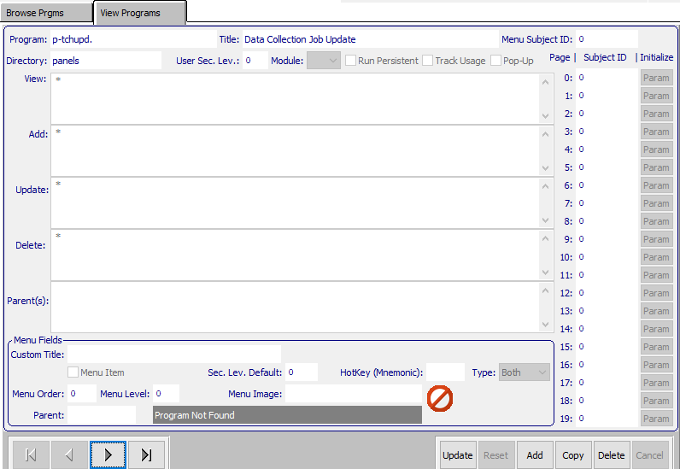

An asterisk (*) within any of these fields means that everyone can access that portion of the program.

#### View ID’s

The *View ID’s* is to set up who can view the data within the currently selected program. This field allows plant personnel to enter data.

#### Add ID’s

The *Add ID’s* is security for who can add data within the currently selected program. This field allows plant personnel to enter data.

#### Update ID’s

The *Update ID’s* is security for who can update existing data within the currently selected program. Set security within this field to specific users or User Groups in order to stop the plant data collection personnel from updating the current date and times.

#### Delete ID’s

The *Delete ID’s* is security for who can delete existing data within the currently selected program. Set security within this field to specific users or User Groups in order to stop the plant data collection personnel from updating the current date and times.

### User Groups

Under ***“N”-“U”-“5”***, the user can add groups, and assign users to that group. Then, if a user is hired or fired, the system administrator may simply change the users within the group that the employee belongs to. Therefore, no security will need to be changed.

If a user does not have access, the selected button will be grayed out.

## Plant Data Collection Security

If the system administrator wishes to lock users out of changing the *Job Time* for Machine Transactions, they may set the security so that users can view their time, but not update it.

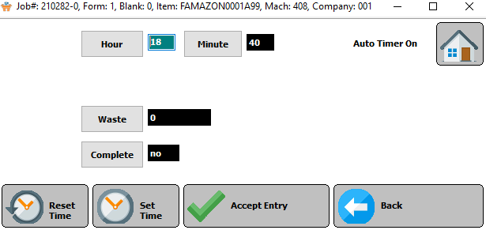

Locking users from changing their time punches will render the *Hour* and *Minute* fields as grayed-out and unclickable.

Please Note: This disallows a user to change their own time punches. (i.e. If they are late to work, they may not change the time to reflect their original start time.)